**Task 1**

You should spend about 20 minutes on this task.

***The bar chart below shows data on top four coffee producing countries in the world from 2011 to 2013***

Summarise the information by selecting and reporting the main features, and make comparisons where relevant.

Write at least 150 words

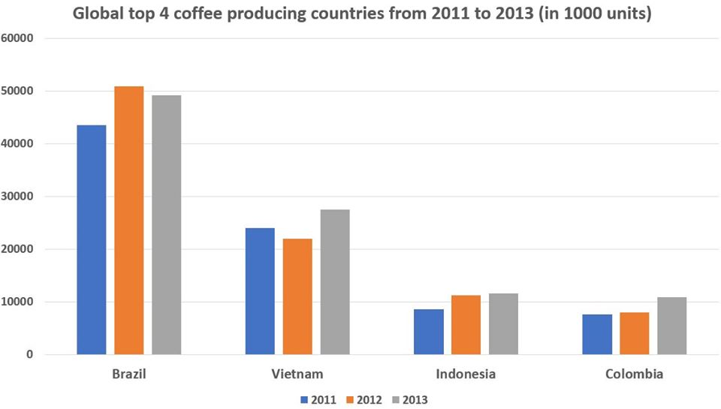

The chart depicts informations about four countries that are the best at generating coffee in the world between 2011 and 2013. Overall, in 2013, three countries have a slight rise compared to other years except Brazil over the three year period. Looking to the bar chart, we can see that 43 million unit were produced in Brazil, which was the highest and doubling the yeld of Vietnam in the second place and in others year the rank didn’t change. Versus Indonesia and Colombia, the output both of them were similar, at approximately 8 millions units. And they were the lowest production. Throughout the years, both nation increase a little bit, at approximately 11 millions units in the last year.